HW 1.1.3 Wie Spät? Name ______________________________ Klasse: ______

A. Um wie viel Uhr?: Write out the time, in German, you do the following activities:

beispiel: shower sechs Uhr zehn. (6h10)

1. get dressed _____________________________
2. eat breakfast _____________________________
4. go to school _____________________________
5. eat lunch _____________________________
6. start German class _____________________________
7. do homework _____________________________
8. watch TV _____________________________
9. talk on the phone _____________________________
10. go to bed _____________________________

B. die Zeit: Write the following times in German.
11:55
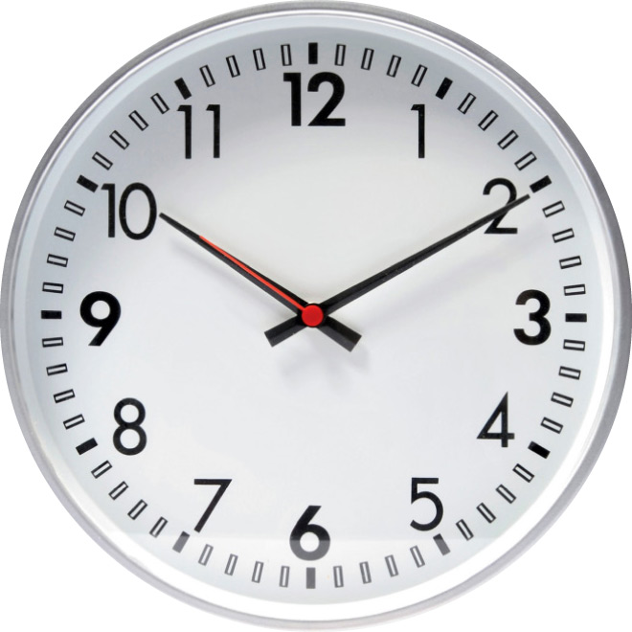
1 _______________________________________
2 _______________________________________
3 _______________________________________
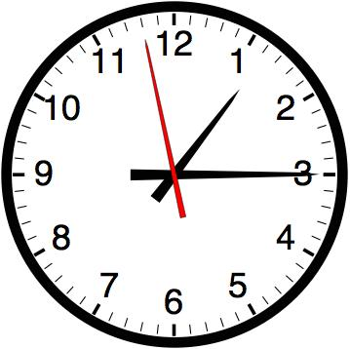
4 _______________________________________
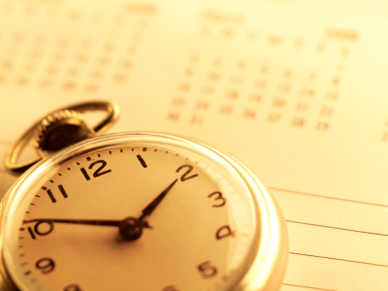
5 _______________________________________
6 _______________________________________
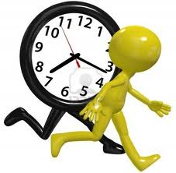
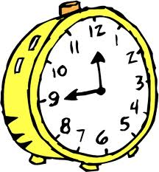
7 _______________________________________
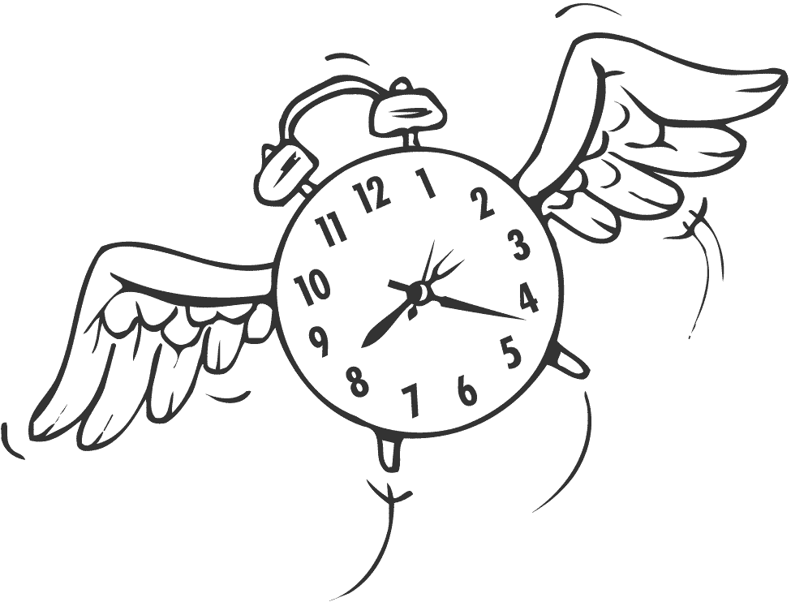

C. Eine Vorstellung: Write out, in German, a short but complete conversation between two students getting to know each other. Include elements from each vocab list.

__________________________________________________________________________________________

_________________________________________________________________________________________

__________________________________________________________________________________________

__________________________________________________________________________________________

__________________________________________________________________________________________

_________________________________________________________________________________________

__________________________________________________________________________________________

__________________________________________________________________________________________

__________________________________________________________________________________________

